Why care about planning?

The big choice
If you care about your home and neighbourhood you need to know a bit about how planning works.

London is a diverse and fast changing city but the changes which are happening around us don’t always benefit our communities. As we begin to move out of the Covid-19 pandemic we have a choice about how we are going live. Do we go back to how things were where many people felt left behind by change? Or do we get active to make our communities fairer, greener and more friendly?

Imagine our communities with less traffic and pollution, more affordable homes, places for children to play and explore, places to grow local food, places that celebrate our diverse culture, places which are designed to offer security to everyone and space for local and social businesses to thrive. Places which put people and their health and wellbeing first. All of this is possible if communities take a strong role in the decisions which affect their lives. That means not taking no for answer and using all the tools communities have to get their voice heard, including the planning system.

The planning system can seem boring and complicated but it’s vital in many of the decisions about our future. Planning Aid London is here to help you find your way through the process and support communities in striving for a better future. Of course, this isn’t easy and getting better outcomes will be a struggle. But the Covid-19 pandemic has shown how important our homes and neighbourhoods are to our future. Let’s make sure we make the most of the opportunity.

If you want more help and training on planning, contact us at www.planningaidforlondon.org.uk
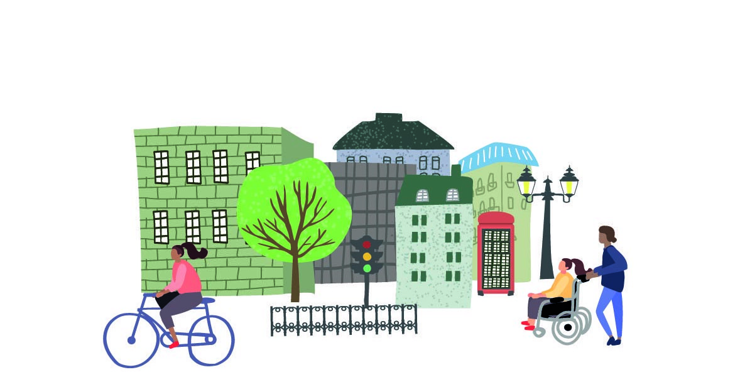

Need further help?
Find more information on our
website or contact us at:
info@planningaidforlondon.org.uk
030 077 29 808
Follow us @Planaidlondon

© Planning Aid for London. January 2021
Registered charity (no. 802943)

With support from Trust for London and the Town and Country Planning Association

